18/10/2026 NAME: Charulatha.V
Experiment :3 REG.NO.:192424031
SLOT: A
SEMESTER:MS2 September 2026
COURSE CODE:CSA4701
COURSE NAME:Deep Learning

Probability Distributions and Bayes’ Theorem
Scenario:
A hospital studies patients' waiting times, which approximately follow a normal distribution. Generate synthetic waiting-time samples, calculate probabilities for specified intervals, and visualize the distribution.
Algorithm:
- Start the program.
- Import NumPy, SciPy, and Matplotlib libraries.
- Get the number of patients, mean waiting time, and standard deviation as input.
- Generate synthetic waiting-time samples using NumPy based on a normal distribution.
- Get the lower and upper limits for the waiting-time interval.
- Calculate the probabilities for the specified interval using SciPy's normal distribution function.
- Apply Bayes’ theorem to calculate the conditional probability using prior probability and test results.
- Display the generated samples and calculated probabilities.
- Plot a histogram of waiting times and the normal distribution curve using Matplotlib.
- Visualize the probability interval by highlighting the corresponding area under the curve.
- Display the results and stop the program.

Source code:

import numpy as np
import pandas as pd
import matplotlib.pyplot as plt
from scipy.stats import norm

# Get input from the user
n = int(input("Enter number of patients: "))
mean = float(input("Enter average waiting time (minutes): "))
std = float(input("Enter standard deviation (minutes): "))

lower = float(input("Enter lower limit for probability (minutes): "))
upper = float(input("Enter upper limit for probability (minutes): "))

if n <= 0 or std <= 0 or lower > upper:
raise ValueError("Enter valid patient count, positive standard deviation, and limits.")

# Generate synthetic waiting-time samples
np.random.seed(42)
waiting_times = np.random.normal(mean, std, n)
waiting_times = np.maximum(waiting_times, 0)

# Create DataFrame
df = pd.DataFrame({
"Patient": range(1, n + 1),
"Waiting Time (minutes)": np.round(waiting_times, 2)
})

print("\nWAITING TIME DATA")
print(df.to_string(index=False))

# Summary table
print("\nSUMMARY TABLE")
print(df["Waiting Time (minutes)"].describe().round(2))

# Calculate theoretical normal distribution probabilities
prob_lower = norm.cdf(lower, loc=mean, scale=std)
prob_upper = norm.cdf(upper, loc=mean, scale=std)
interval_probability = prob_upper - prob_lower

print("\nPROBABILITY RESULTS")
print(f"P(X <= {lower}) = {prob_lower:.4f}")
print(f"P(X <= {upper}) = {prob_upper:.4f}")
print(f"P({lower} <= X <= {upper}) = {interval_probability:.4f}")
print(f"Interval probability = {interval_probability * 100:.2f}%")

# Bayes' theorem example:
# A = patient has a condition
# B = screening test is positive
prior = float(input("\nEnter probability of condition P(A) (0 to 1): "))
sensitivity = float(input("Enter P(positive test | condition) (0 to 1): "))
false_positive = float(input("Enter P(positive test | no condition) (0 to 1): "))

if not (0 <= prior <= 1 and 0 <= sensitivity <= 1
and 0 <= false_positive <= 1):
raise ValueError("Probabilities must be between 0 and 1.")

positive_probability = (
sensitivity * prior + false_positive * (1 - prior)
)

if positive_probability > 0:
posterior = sensitivity * prior / positive_probability
print(f"P(condition | positive test) = {posterior:.4f}")
print(f"Posterior probability = {posterior * 100:.2f}%")
else:
print("Posterior probability is undefined because P(positive test) is zero.")

# Plot 1: Histogram and normal distribution curve
x = np.linspace(max(0, mean - 4 * std), mean + 4 * std, 400)
y = norm.pdf(x, loc=mean, scale=std)

plt.figure(figsize=(8, 5))
plt.hist(waiting_times, bins=15, density=True,
alpha=0.6, edgecolor="black", label="Synthetic samples")
plt.plot(x, y, linewidth=2, label="Theoretical normal curve")
plt.axvline(lower, linestyle="--", label="Lower limit")
plt.axvline(upper, linestyle="--", label="Upper limit")
plt.xlabel("Waiting Time (minutes)")
plt.ylabel("Density")
plt.title("Hospital Waiting Time Distribution")
plt.legend()
plt.tight_layout()
plt.show()

# Plot 2: Highlight the probability interval
plt.figure(figsize=(8, 5))
plt.plot(x, y, linewidth=2)
mask = (x >= lower) & (x <= upper)
plt.fill_between(x[mask], y[mask], alpha=0.4)
plt.xlabel("Waiting Time (minutes)")
plt.ylabel("Probability Density")
plt.title(f"Probability Between {lower} and {upper} Minutes")
plt.tight_layout()
plt.show()

print("\nRESULT")
print("Waiting-time samples, probabilities, and plots generated successfully.")

Output:

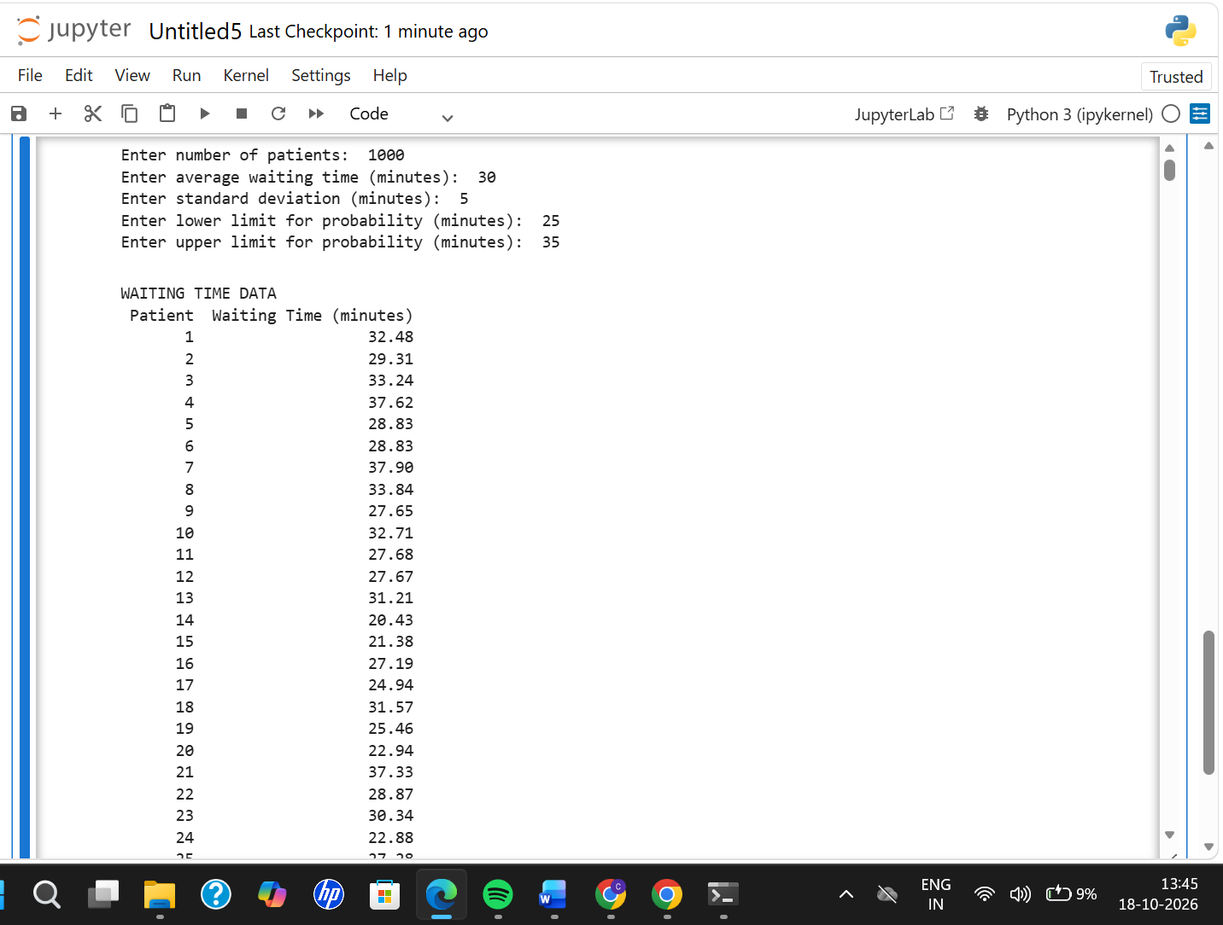
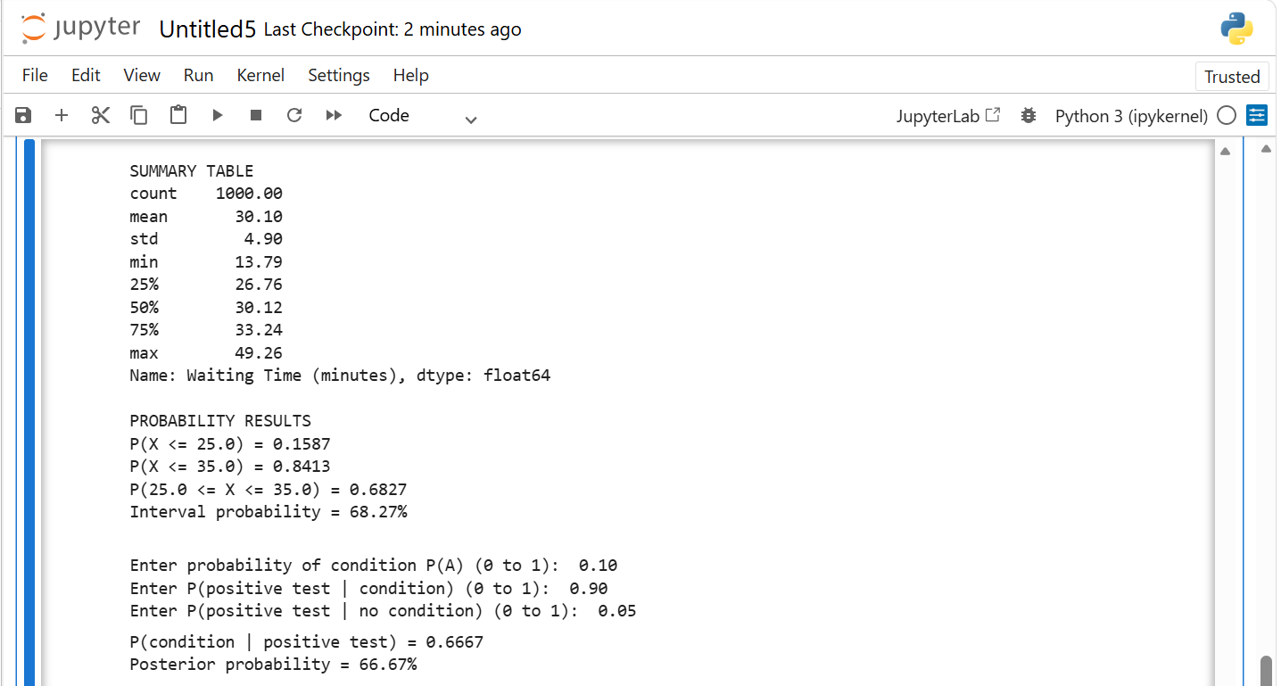
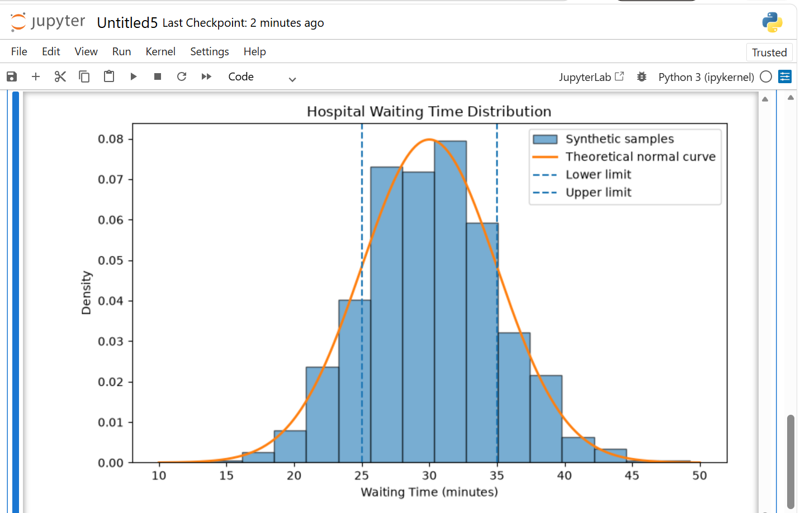
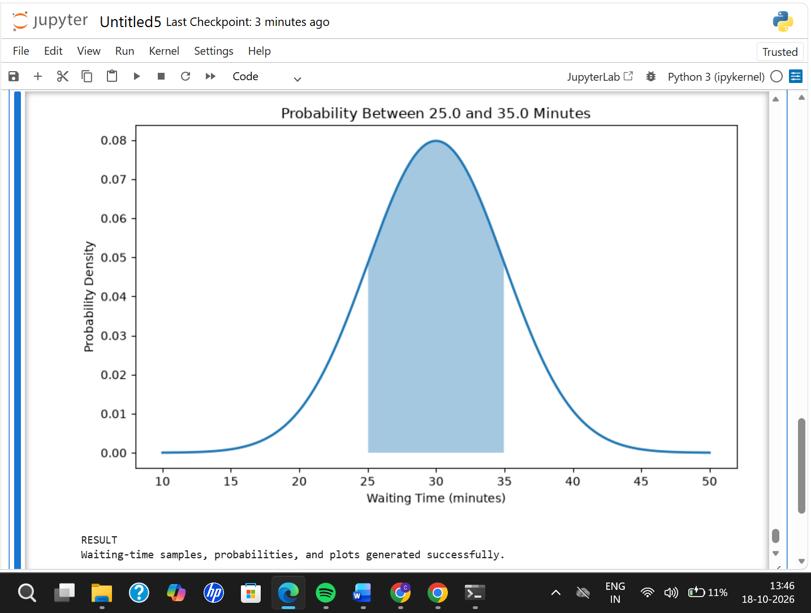

Result:
Synthetic patient waiting-time samples were generated using NumPy. Probabilities for specified intervals were calculated using SciPy, and Bayes’ theorem was applied to determine conditional probability. The waiting-time distribution and probability intervals were successfully visualized using Matplotlib.

